Git integrate with Jenkins slave using github webhook

* Shweta Raut

Create a Jenkins slave on Jenkins dashboard

Manage Jenkins > nodes

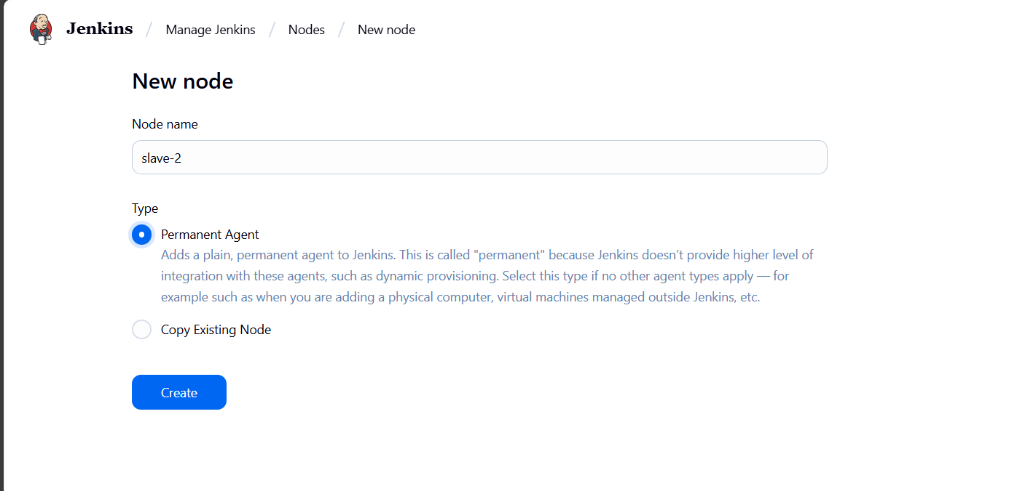

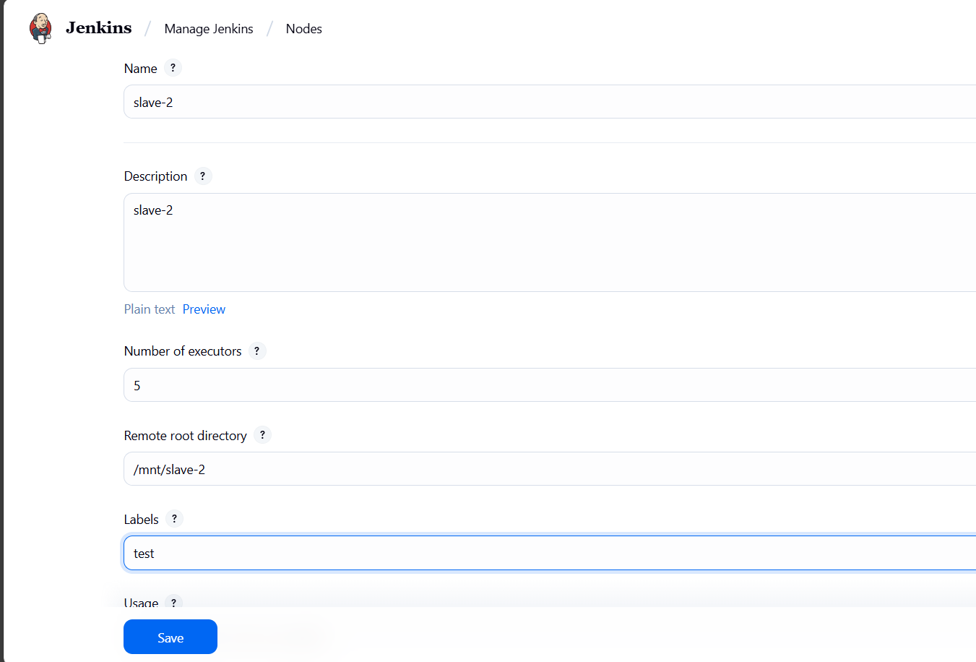

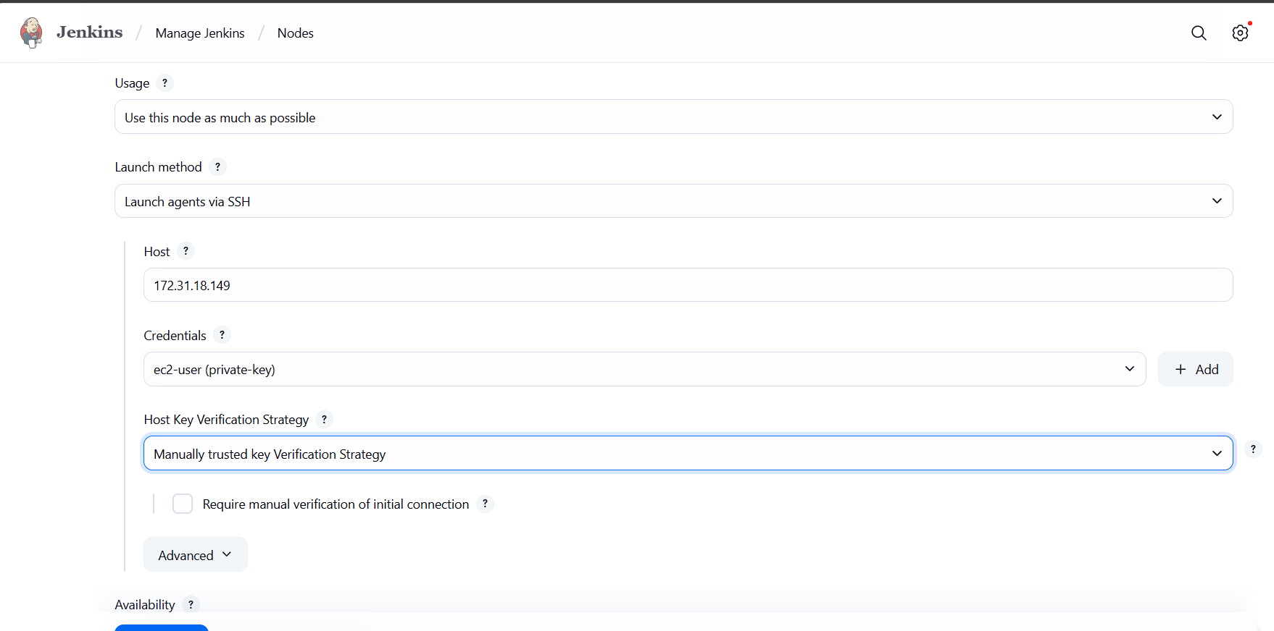

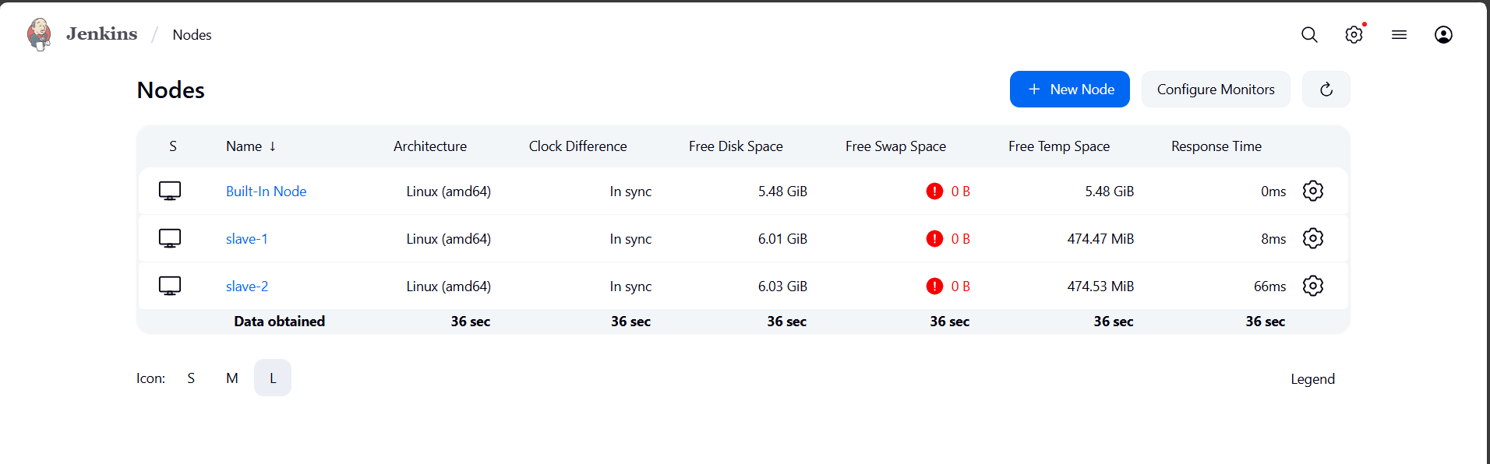

Add private key as a credential

Host: private ip of ec2

Permissions: to remote root directory (chmod -R 777 /mnt/slave-2)

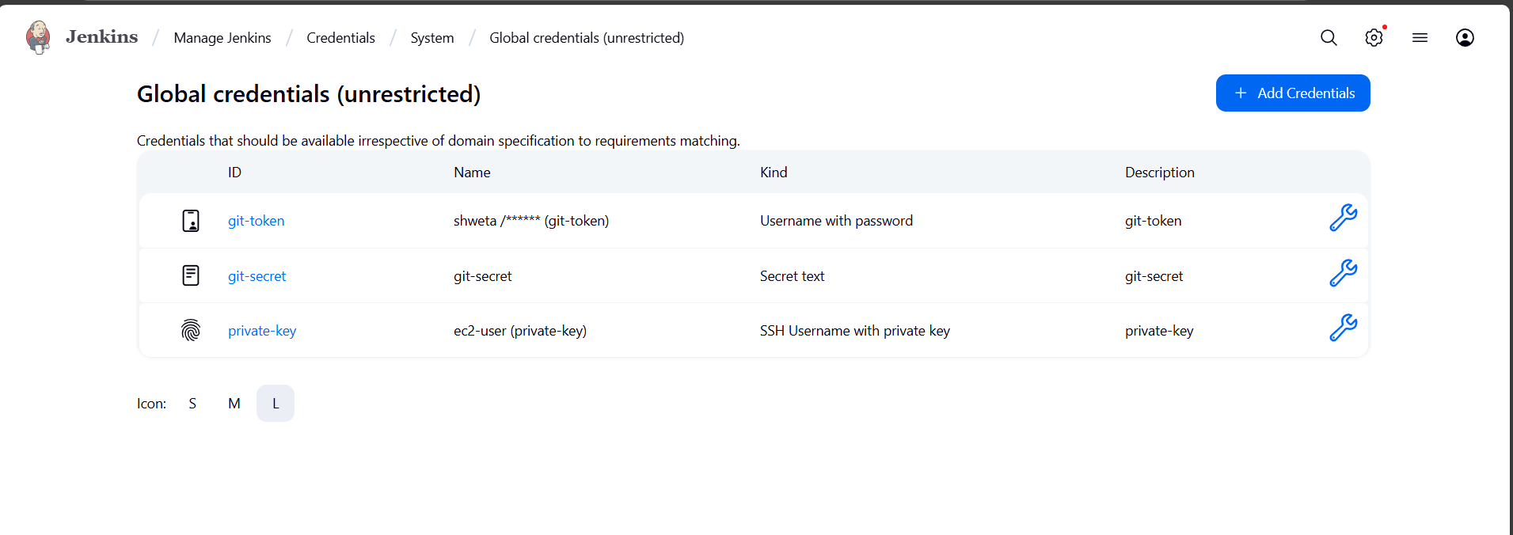

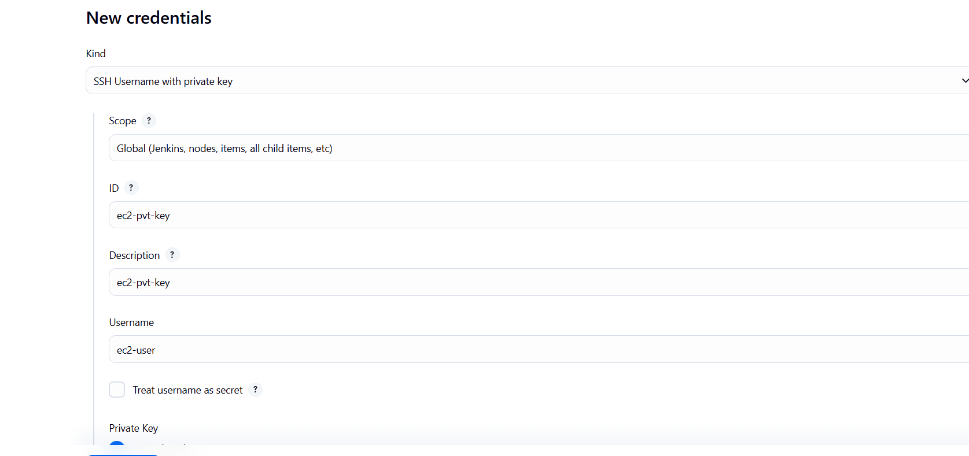

Create a freestyle job 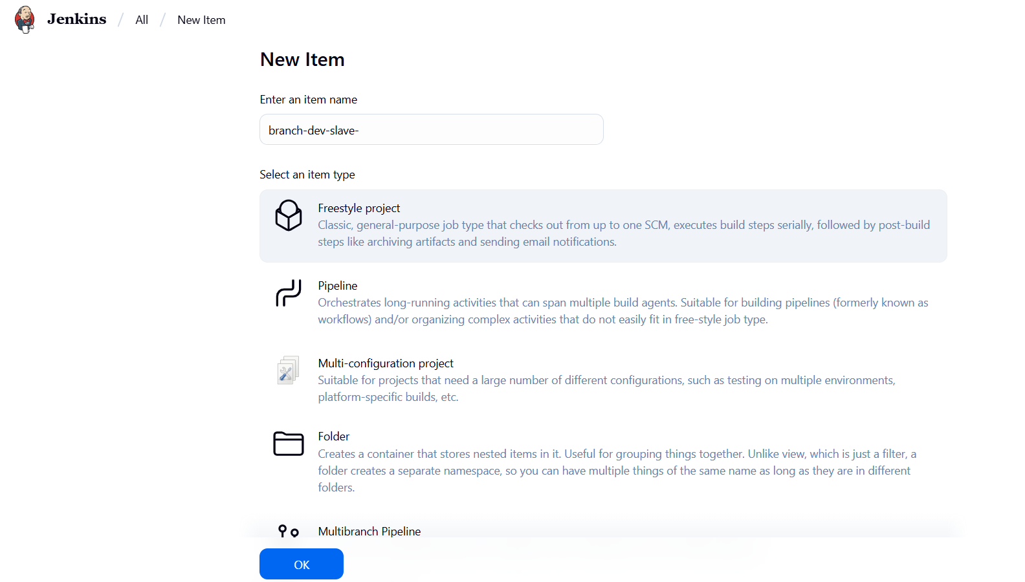

Manipulate where you want to run project

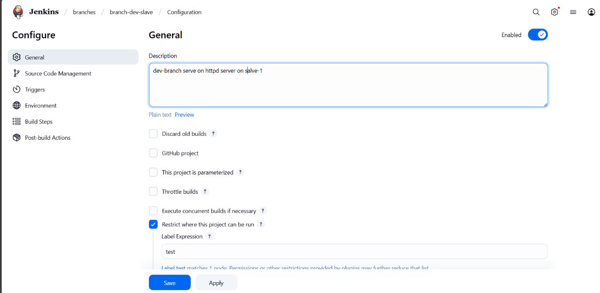

Make sure webhook is configure in github repo

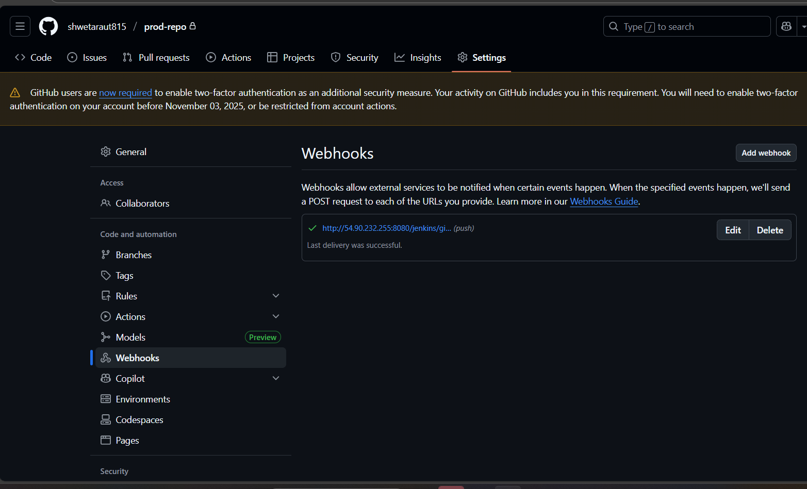

Integrate git repo with Jenkins with branch dev, make sure git is installed in backend on slave also

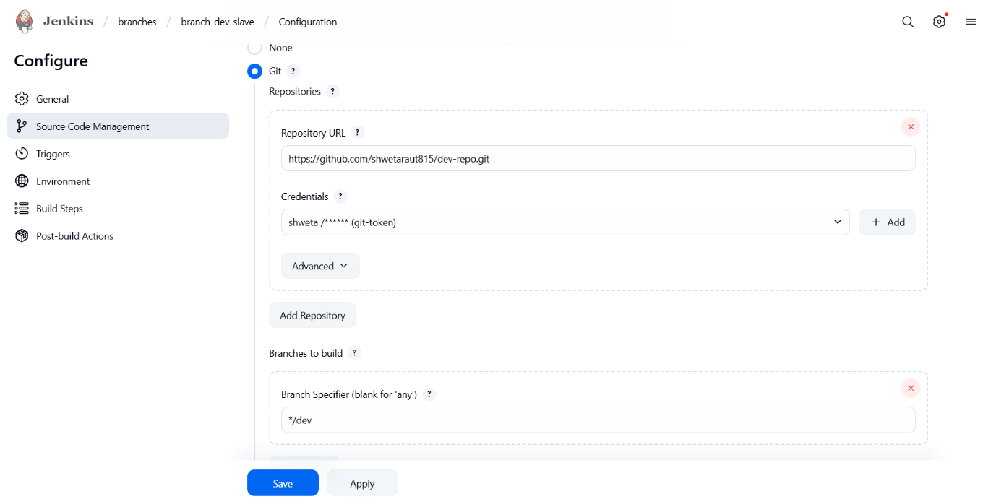

As I want to trigger my job after any changes in github repo so here I have to add github webhook.

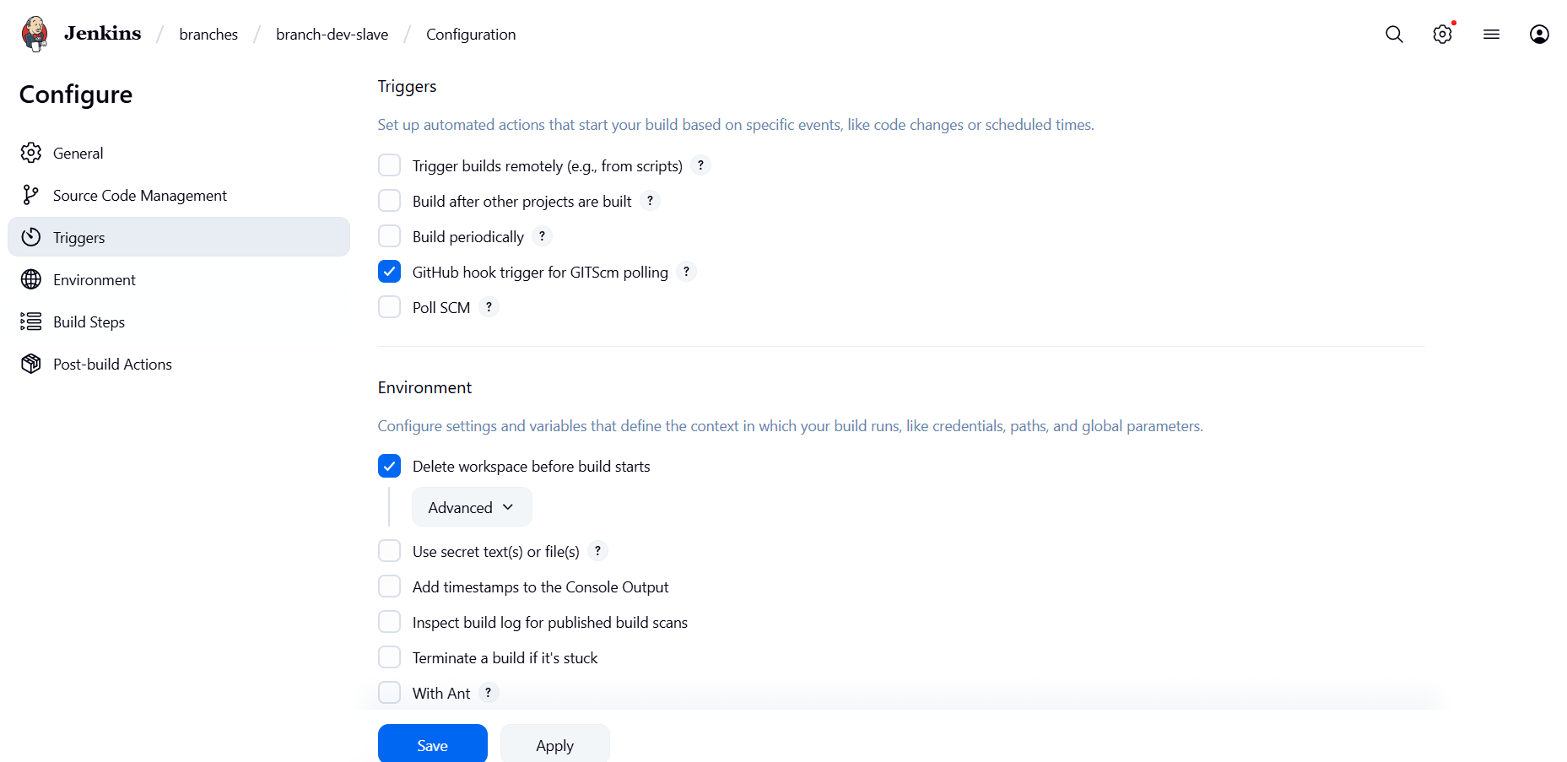

Add script to execute the job

Copy my index.html file in github to /var/www/html folder on the slave

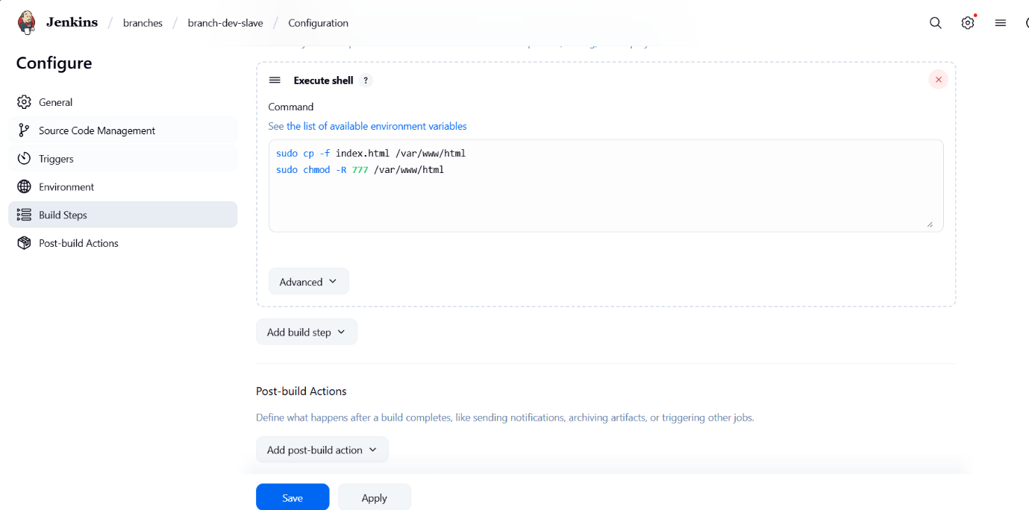

Now when I change my code in github my job is triggered everytime to make my build updated



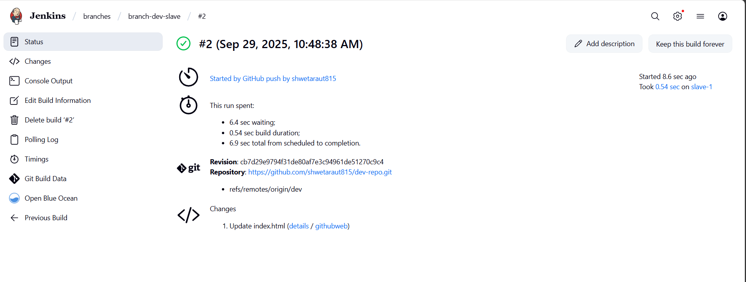

Do it same for all other branches ( qa, prod )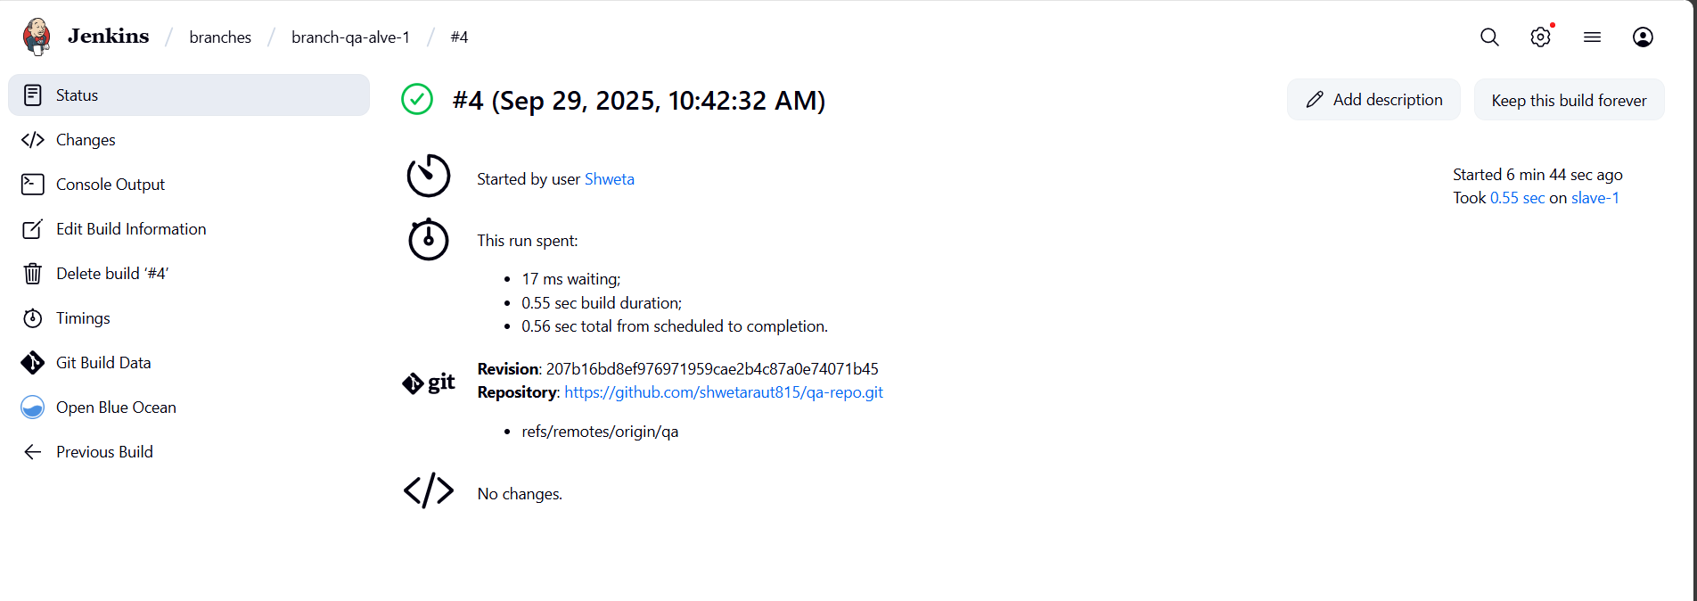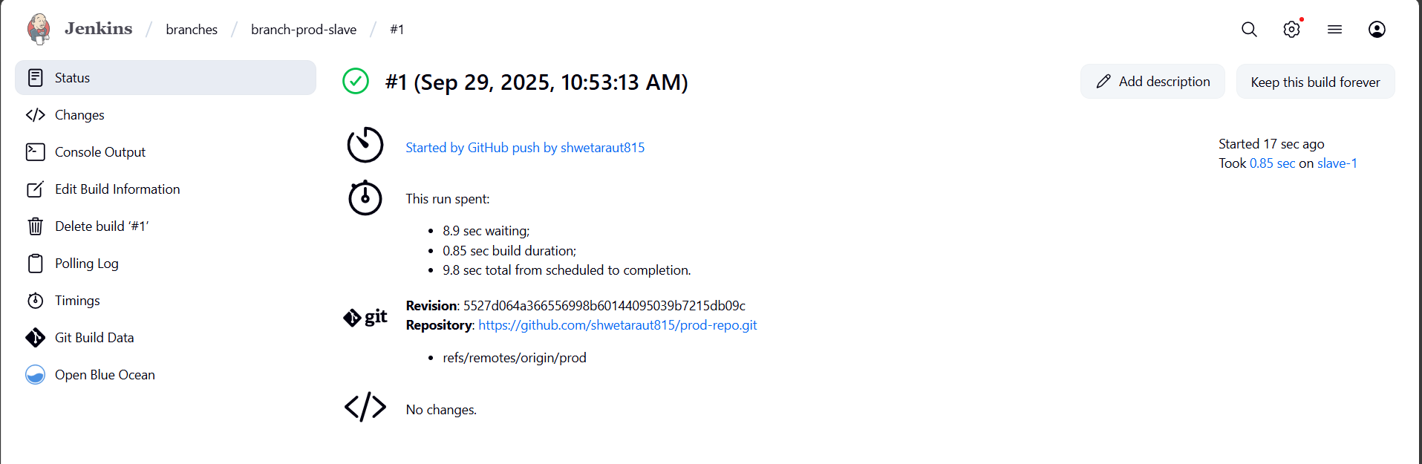

Now when I access httpd server over the browser I get the webpage of recent changed build